**Azure devops**

**1.Introduction to DevOps**

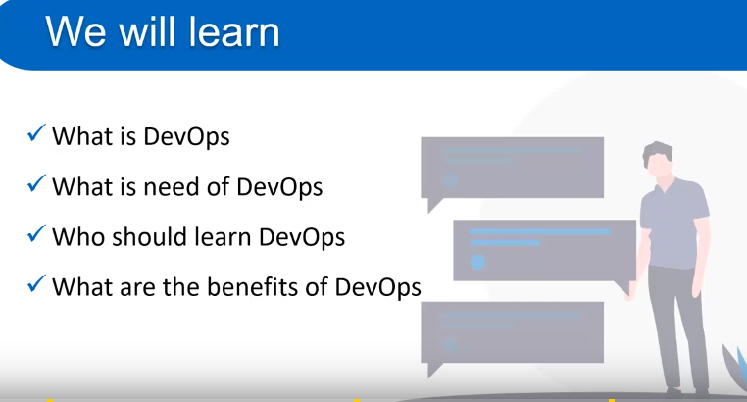 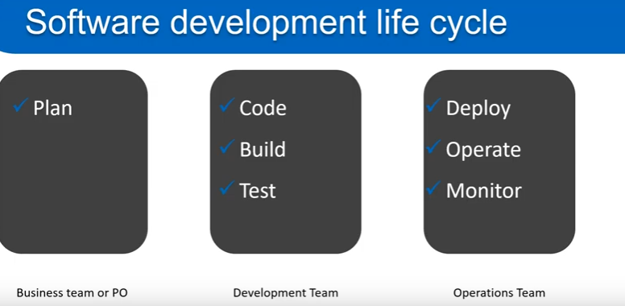 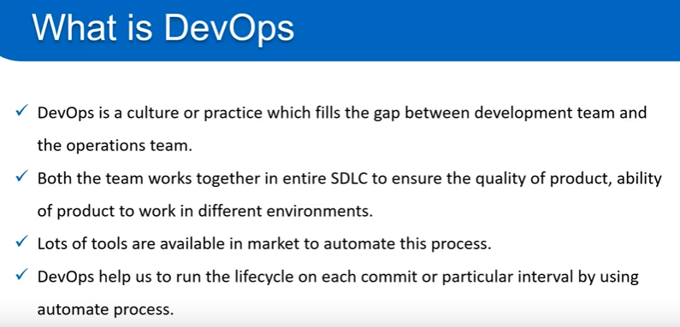 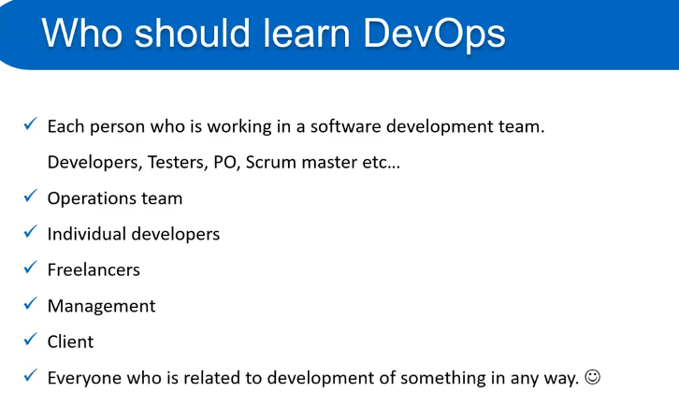 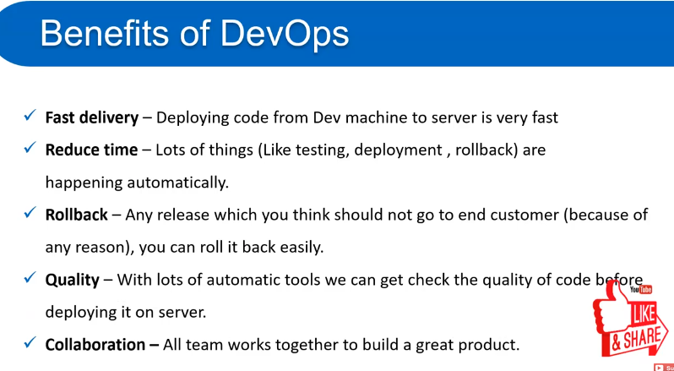 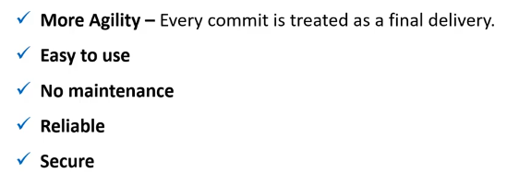

# 2. What is Azure DevOps:

# 

# 3. Create an account on Azure DevOps:

# 

# 4. Create an organization in Azure DevOps

# 

# Create an organization on Azure devops:

# Login toAzure devops account 🡪 Whenever you login in to Azure devops an organization is created automatically but we can create our own organization also.

# Whenever we login to Azure devops on the left hand side there is an organization named My Organizations is already available and under that organization there is only one organization named deepak10numbari is available this is coming under the email we have used.

# In the bottom part of this page a + symbol is available

# 

# Once we click on + button to create a new organization a new popup will be created

# 

# Here a new organization named sample-org is created and once this organization is created there is an option called Organization Settings click on that In the left menu bar there are multiple options are available like General, Security, Boards and Pipelines

# 5.Create a project in Azure DevOps :

# 

# How to create a project?

# Create an organization 🡪click onCreate Project button 🡪fill the project name, Description,

# 

# Once We click on Create button All the 5 services of Azure devops like Boards, Repos, Pipelines, Test Plans and Artifacts are available there.

# Project Settings :-

# We will have a link at bottom left of the page named Project Settings

# 

# Once we click on that button the above window will be open

# Teams option is also available there and the name of team will be default name Sample-Mobile-Application Team same as project name similarly Security , notifications are also available.

# 6. Setup a Team for project in Azure DevOps

# 

# How to invite a new member in the team:

# Threre are multiple ways to invite a member in a team Fisrt one is : There is an invite button on the top right corner 🡪if you click on this button we search user for this project

# What is Azure boards?

# Azure board with basic process

# 

# Epic : Epic is basically a kind of functionality or a kind of large work.it is also called membership eg: Implementing Login Functionality

# Issue : Under the epic we can create multiple types of issue. Issue might be a bug ,user story , improvement etc all this are the part of issue. Like login functionality, Signup functionality, Forgot password etc.

# Task : Task is the smallest unit of work. To implement Login Functionality there could be multiple tasks like Creating a table in Database is one task,

# 

# Kanban Board :

# Select a Project (named Sample-Mobile-Application) 🡪Click on Boards 🡪Boards 🡪Done

# A new Kanban board is created with three columns To Do /Doing and Done

# 

# In the right corner dropdown there are two options Epics and Issues we can select any one of them

# One Epic can have multiple Issues :

# 

# Work item in Azure board | Work item fields

# 

# 

# Create backlog in Azure Board

# 

# How to Create Backlog in Azure Devops Portal : Labs

# Sprints in Azure Board

# 